GAME DEVELOPMENT

UNITY BASICS

LECTURE 1 (Created by Syed Shaheer Ali)

**CREATING NEW PROJECT**

1. SELECT New project

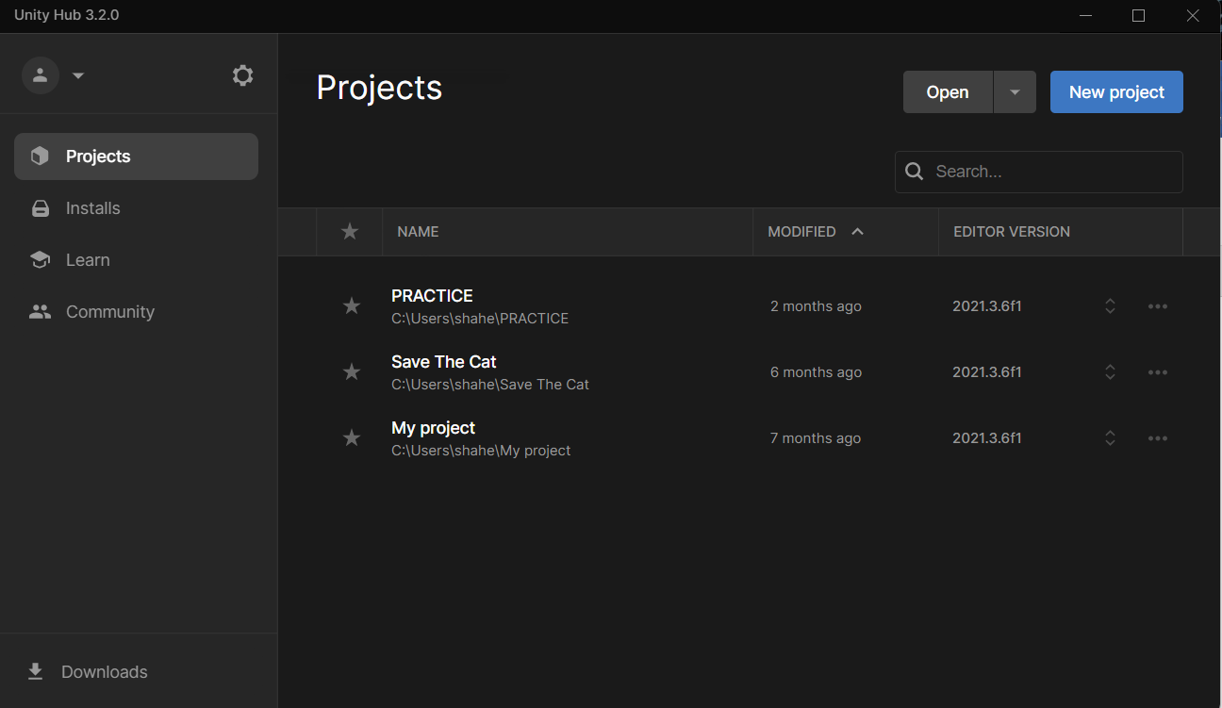

1. Enter Project Name and Select 3D(We will be creating 3D game).

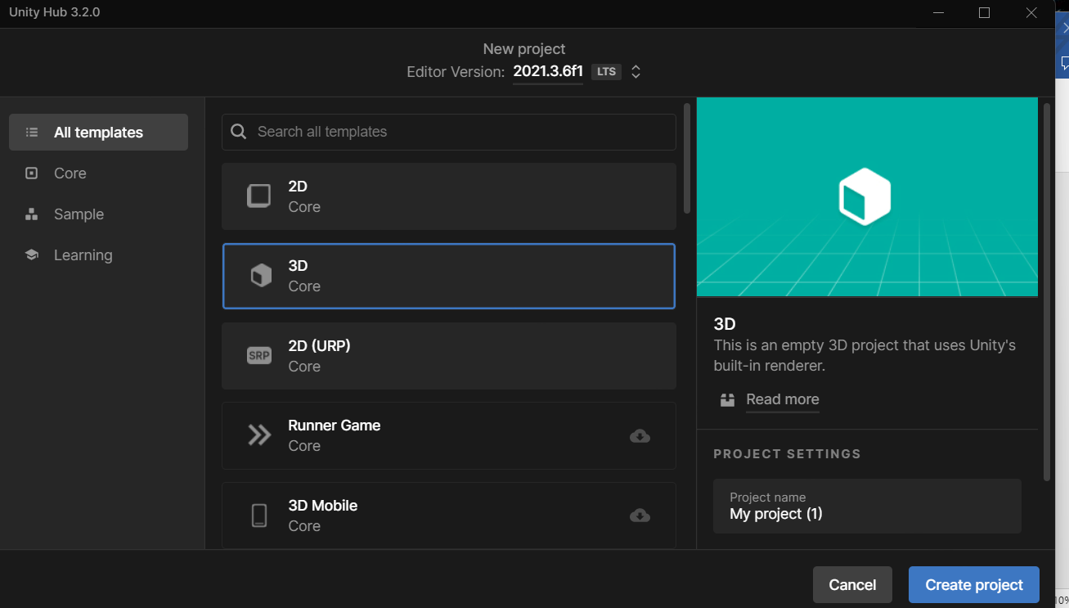

**UNDERSTANDING THE ELEMENTS OF UNITY**

Once you have created the project you will be introduced with such interface.

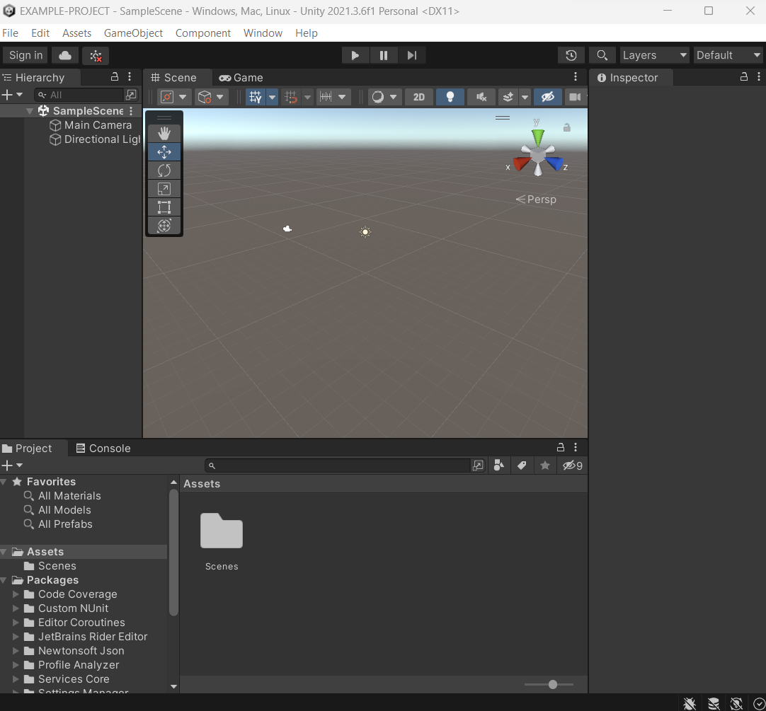

You can see Scenes, Camera, Directional Light.

Here Scenes can be used for different level, or even create menu for the game.

1. Scene view
2. Game View
3. Hierarchy
4. Project view
5. Console

**LET’S MAKE YOUR FIRST GAME**

1. Creating a cube (Right click on Hierarchy Tab)

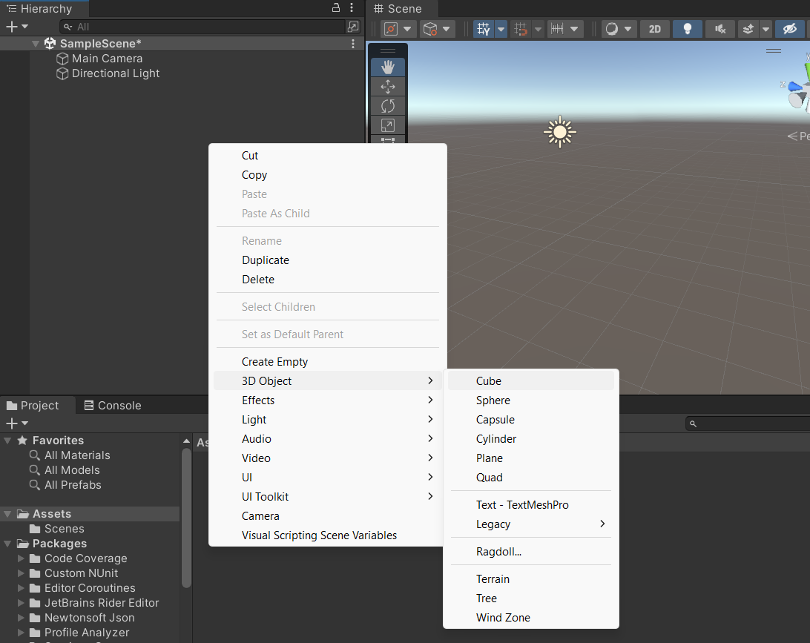

On the inspector menu of the cube, we are presented with

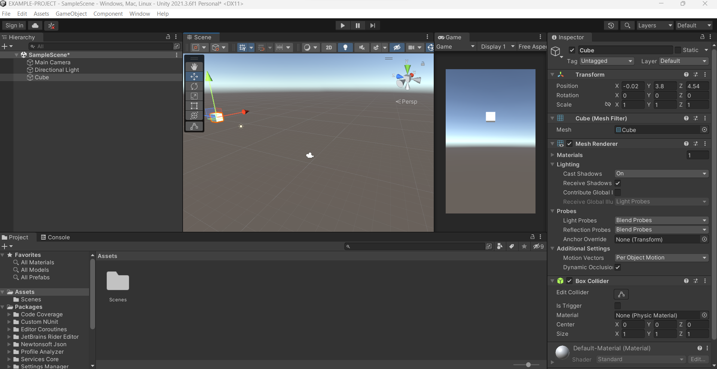

**Transformation (3 Vector) -- up(green), right(red), forward(blue)**

* 1. For Movement
  2. Change Direction
  3. Size Of the cube

**Mesh Filter**

1. Changing the object Shape (Example of Geometry Dash)

**Box Collider**

**SCRIPTING IN C#**

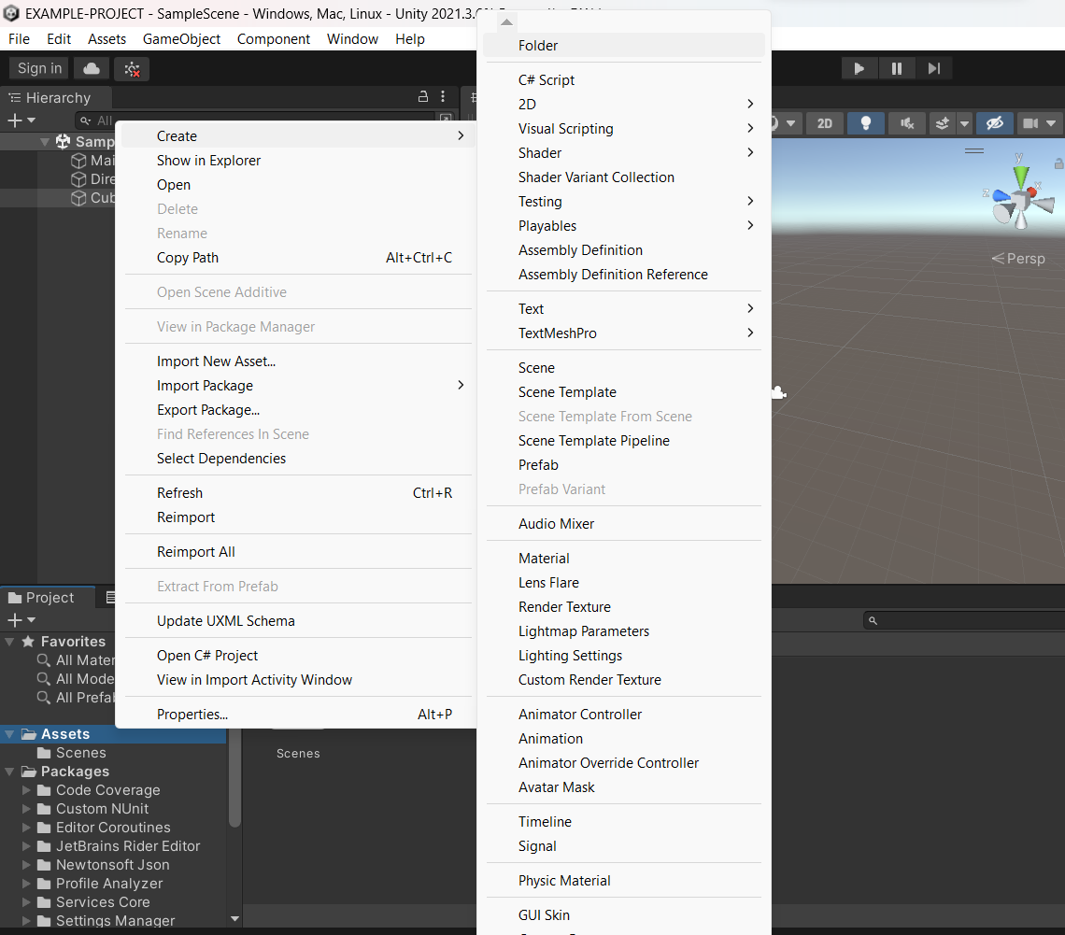

Right click on assets tab and create a **Scripts** folder

And in that folder make a NAME.**cs** C# Script

Now add that script to the game object for it to act on.

Click on add component and search for your script.

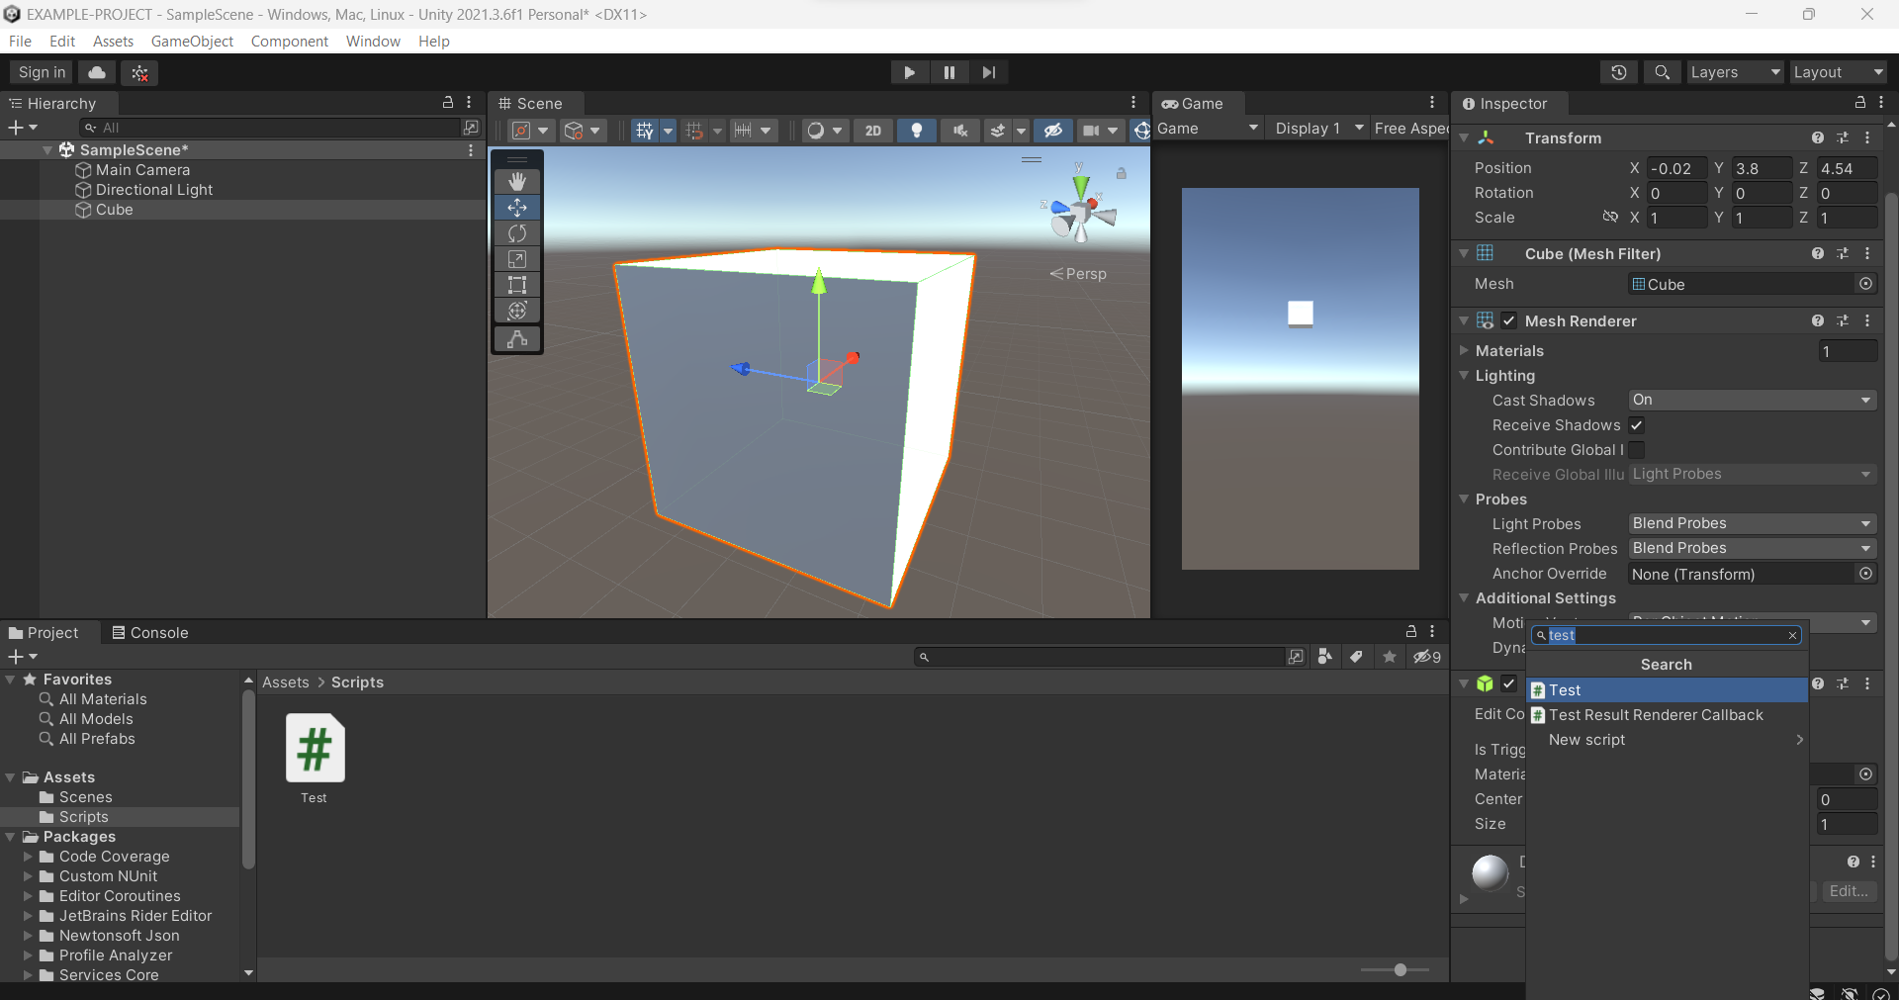

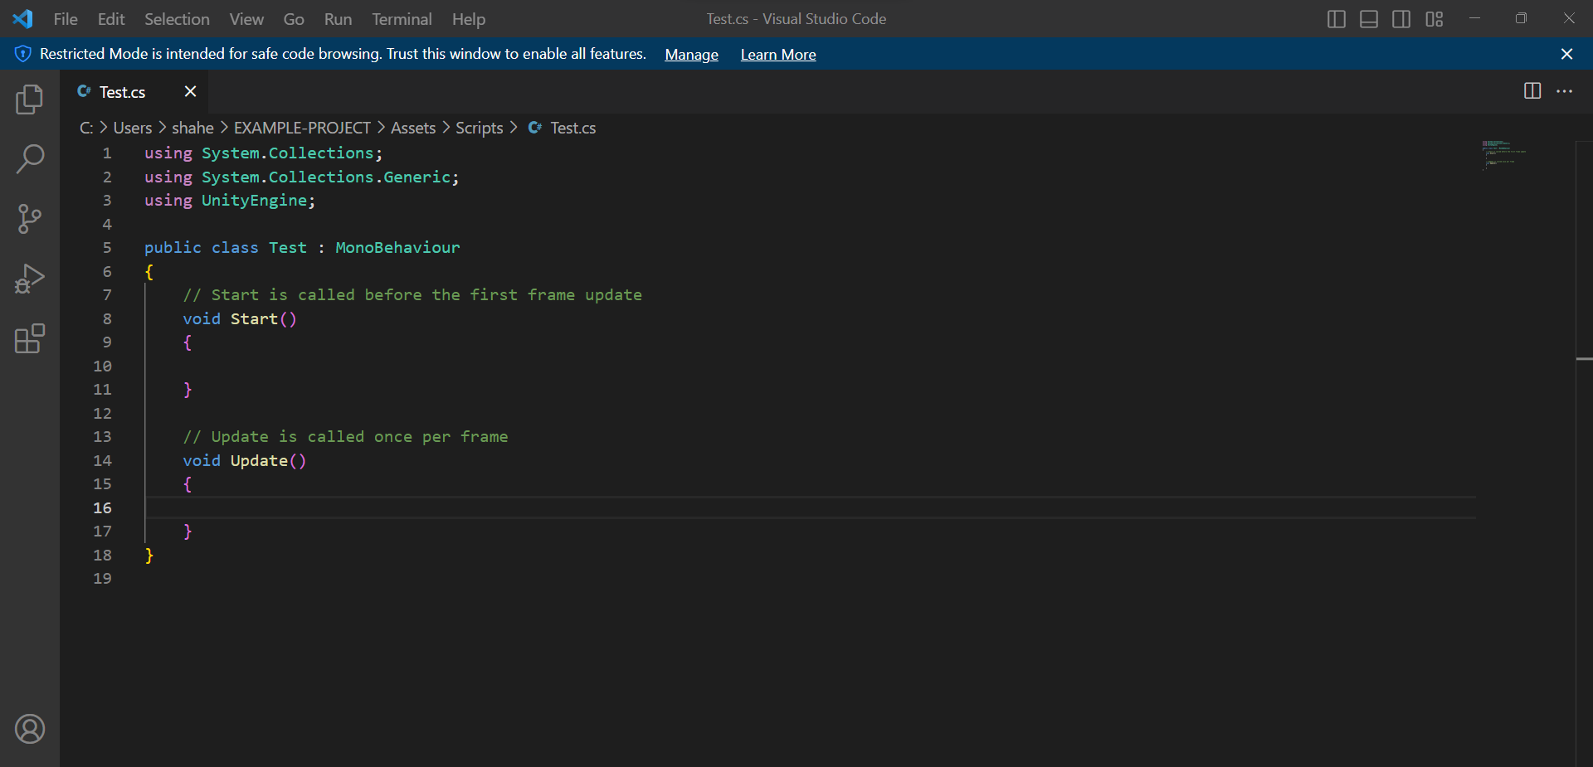

This is what you will be presented in VS Code

We will be using two types of variables

Public variable

public float speed=10;

Private Variable

[SerializeField] private float speedx= 0.2f

LET’S MAKE THE CUBE MOVE

ROTATING IT

        transform.Rotate(Vector3.up, angle: speed*Time.deltaTime)

        //Speed*delta time is for frame

        //vector3.up is the green arrow in unity

MOVING IT

 transform.Translate(new Vector3(x: 0, y: 0, z: 0.1f));

        //right vector   - x

        //up vector      - y

        //forward vector - z

TAKING INPUT FROM USER

KEYBOARD

Input.GetKey(KeyCode.W)

MOUSE

Input.GetMouseButton(0)

CAM MOVEMENT

    public Transform player; //ASSIGN PLAYER OBJECT TO BE FOLLOWED IN CAM

    public Vector3 offset; // ASSIGN THE Distance from the object

    // Update is called once per frame

    void Update()

    {

        transform.position= player.position+offset;}

**ADDING MATERIALS**

Create a Material Folder

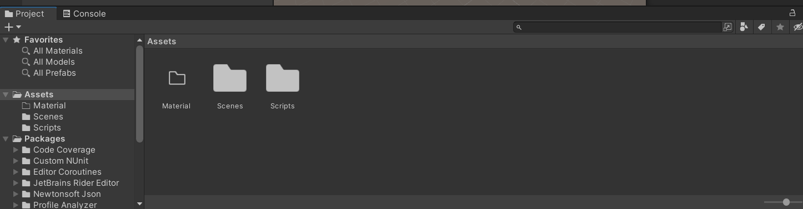

Create new material

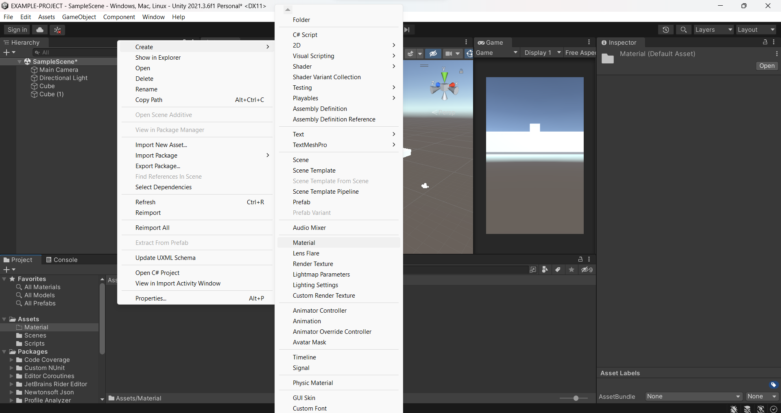

Add that material

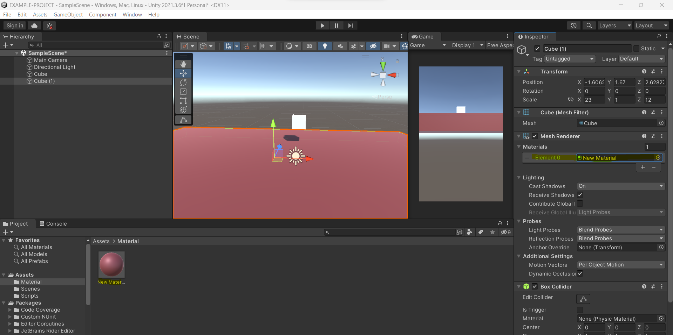

**BASIC PHYSICS**

GRAVITY

